**VIP2023 - Industry Problem Statement**

**NETWORKING**

**Problem Statement: Packet Flow Visualization**

The main objective of this project is to create a visual representation of the packet flow from students' laptops/desktops (hosts) to external networks outside of the college campus.

**1.Network Topology Creation:**

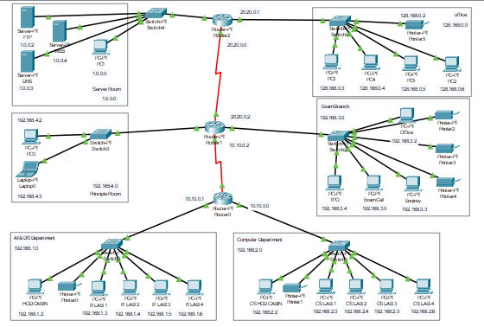

**2. Packet Flow Investigation:**

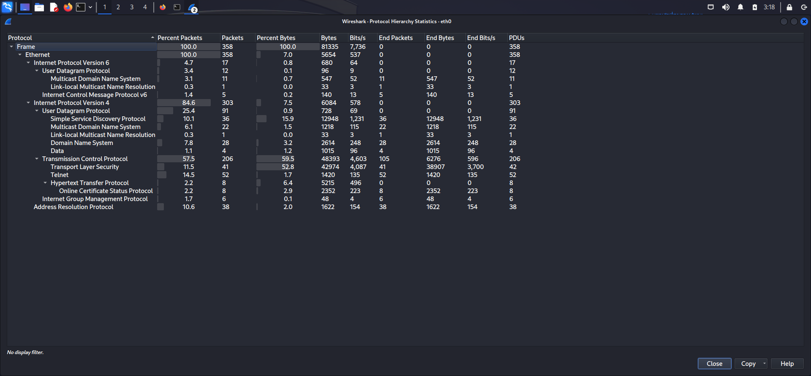

**Ethernet:**

**1.Internet Protocol Version 6:**

**A. User Datagram Protocol**: User Datagram Protocol (UDP) is a communications protocol that is primarily used to establish low-latency and loss-tolerating connections between applications on the internet.

1. **Multicast Domain Name System**: In computer networking, the **multicast DNS** (**mDNS**) protocol resolves hostname, to IP addresses within small networks that do not include a local name server. It is a zero-configuration service, using essentially the same programming interfaces, packet formats and operating semantics as unicast Domain Name System (DNS). It was designed to work as either a stand-alone protocol or compatibly with standard DNS servers. It uses IP multicast User Datagram Protocol (UDP) packets and is implemented by the Apple Bonjour and open source Avahi software packages, included in most Linux distributions. Although the Windows 10 implementation was limited to discovering networked printers, subsequent releases resolved hostnames as well. mDNS can work in conjunction with DNS Service Discovery (DNS-SD), a companion zero-configuration networking technique specified separately in RFC 6763.
2. **The Link-Local Multicast Name Resolution (LLMNR):** A protocol based on the Domain Name System (DNS) packet format that allows both IPv4 and IPv6 hosts to perform name resolution for hosts on the same local link.

**B. Internet Control Protocol V6:** Internet Control Message Protocol version 6 is the implementation of the Internet Control Message Protocol for Internet Protocol version 6. ICMPv6 is an integral part of IPv6 and performs error reporting and diagnostic functions. ICMPv6 has a framework for extensions to implement new features.

**2. Internet Protocol Version 4:**

**A. User Datagram Protocol:** User Datagram Protocol (UDP) is a communications protocol that is primarily used to establish low-latency and loss-tolerating connections between applications on the internet

1. **Simple Service Discovery Protocol**: SSDP stands for Simple Service Discovery Protocol. It is a network protocol used for discovering and advertising network services and devices in a local area network (LAN). SSDP operates over the User Datagram Protocol (UDP) and is part of the Universal Plug and Play (UPnP) suite of protocols. The primary purpose of SSDP is to allow devices and services to announce their presence and capabilities on a network, enabling other devices to discover and interact with them. It works in a client-server model, where devices can act as both SSDP clients and SSDP servers.
2. **Multicast Domain Name System**: In computer networking, the **multicast DNS** (**mDNS**) protocol resolves hostname, to IP addresses within small networks that do not include a local name server. It is a zero-configuration service, using essentially the same programming interfaces, packet formats and operating semantics as unicast Domain Name System (DNS). It was designed to work as either a stand-alone protocol or compatibly with standard DNS servers. It uses IP multicast User Datagram Protocol (UDP) packets and is implemented by the Apple Bonjour and open source Avahi software packages, included in most Linux distributions. Although the Windows 10 implementation was limited to discovering networked printers, subsequent releases resolved hostnames as well. mDNS can work in conjunction with DNS Service Discovery (DNS-SD), a companion zero-configuration networking technique specified separately in RFC 6763.
3. **The Link-Local Multicast Name Resolution (LLMNR):** A protocol based on the Domain Name System (DNS) packet format that allows both IPv4 and IPv6 hosts to perform name resolution for hosts on the same local link.
4. **Domain Name System**: Domain Name System (DNS) is a hostname for IP address translation service. DNS is a distributed database implemented in a hierarchy of name servers. It is an application layer protocol for message exchange between clients and servers. It is required for the functioning of the Internet.

**B. Transmission Control Protocol:** Transmission Control Protocol (TCP) is a communications standard that enables application programs and computing devices to exchange messages over a network. It is designed to send packets across the internet and ensure the successful delivery of data and messages over networks.

1. **Transport Layer Security Protocol: Transport layer security protocol is** one of the security protocols which are designed to facilitate privacy and data security for communications over the Internet. The main use of TLS is to encrypt the communication between web applications and servers, like web browsers loading a website. TLS is used to encrypt other communications like email, messaging, and voice over IP (VoIP). TLS was proposed by the Internet Engineering Task Force (IETF), which is an international standards organization.
2. **Telnet: Telnet is a network protocol and application that allows you to establish a command-line connection to a remote server or device over a TCP/IP network. It provides a text-based interface through which you can communicate with the remote system, typically a Unix or Linux server.**
3. **Hypertext Transfer Protocol:** The Hypertext Transfer Protocol (HTTP) is the foundation of the World Wide Web and is used to load webpages using hypertext links. HTTP is an application layer protocol designed to transfer information between networked devices and runs on top of other layers of the network protocol stack.
4. **Online Certificate Status Protocol:** The Online Certificate Status Protocol (OCSP) is a network protocol used to obtain the revocation status of an X.509 digital certificate. It serves as an alternative to certificate revocation lists (CRLs) and provides a more efficient and timely method of checking whether a certificate is still valid or has been revoked.

**C. Internet Group Management Protocol:** The Internet Group Management Protocol (IGMP) is a communications protocol used by hosts and adjacent routers on IPv4 networks to establish multicast group memberships. IGMP is an integral part of IP multicast and allows the network to direct multicast transmissions only to hosts that have requested them.

**3. Address Resolution Protocol:**

Address Resolution Protocol (ARP) is a protocol or procedure that connects an ever-changing Internet Protocol (IP) address to a fixed physical machine address, also known as a media access control (MAC) address, in a local-area network (LAN).